





**CUSTOMER**

**SEGMENTATION**

**USING DATASCIENCE**

*TABLE OF CONTENTS*

## 1.Introduction

2. Data collection

3. Exploratory Data Analysis (EDA)

4. Customer Segmentation Methods

5. Data Modeling

6. Segment Description

7. Segmentation Results

8. Business Impacts

9. Recommendation

10. Implementation plan

11. Monitoring and Evaluation

12. Conclusion

13. Acknowledgement

1. INTRODUCTION

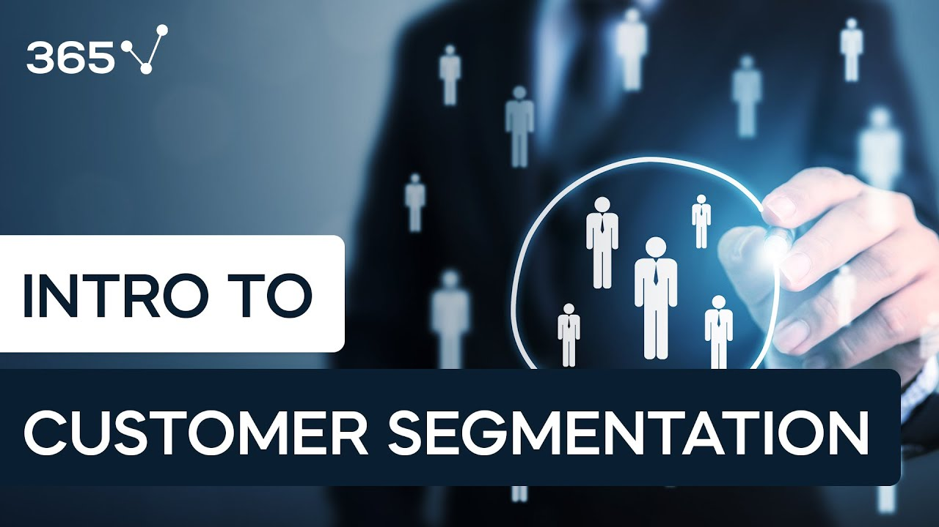

## 

## Customer segmentation involves implementing data science methods to divide the customer base into smaller groups based on certain characteristics. It assists marketing managers in better understanding their customers' preferences and presenting them with better-targeted advertisements Customer.

1.1 Goals:

The primary goals of customer segmentation in business and marketing are to enhance the understanding of your customer base and to facilitate more effective and targeted marketing and business strategies.

A consumer market is a system where customers buy products and services for consumption or sharing with others rather than for reselling. Most of the products in this market are consumer needs for daily lives. A consumer market allows individuals to purchase products and services.

1.2 Objectives:

By segmenting customers based on their individual needs and preferences, companies can increase customer satisfaction and loyalty. Machine learning can also help companies save money by identifying which customers are likely to churn and taking steps to prevent it.

Segmentation research helps companies identify groups of current and potential customers or users with the highest profitability potential. This is one of the pillars of strategic marketing and product development. The other pillars are product positioning and target marketing.

2. DATA COLLECTION



Data collection is the process of gathering and measuring information on variables of interest, in an established systematic fashion that enables one to answer stated research questions, test hypotheses, and evaluate outcomes.

USES:

Data collection is the process of gathering data for use in business decision-making, strategic planning, research and other purposes

3. EXPLORATORY DATA ANALYSIS

(EDA):

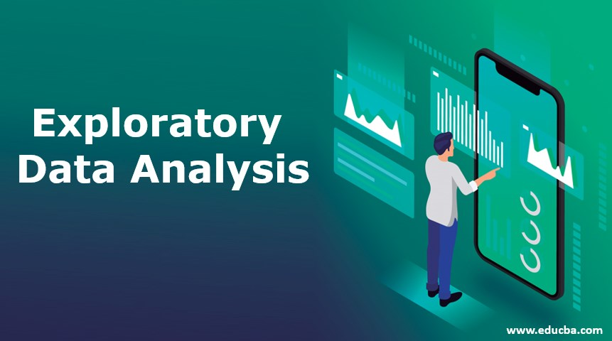

Exploratory Data Analytics (EDA) for customer segmentation involves:

1. Data Collection: Gather relevant customer data.
2. Data Cleaning: Preprocess data to handle missing values and outliers.
3. Descriptive Stats: Compute basic statistics for numerical and categorical variables.
4. Data Visualization: Create visualizations to understand data distributions and relationships.
5. Customer Profiling: Summarize customer characteristics.
6. Feature Selection: Choose relevant features for segmentation.
7. Clustering Analysis: Use initial clustering techniques to explore potential segments.
8. Segment Validation: Assess cluster quality with validation measures.
9. Visualization: Visualize segment characteristics for insights.

4. CUSTOMER SEGMENTATION METHODS:

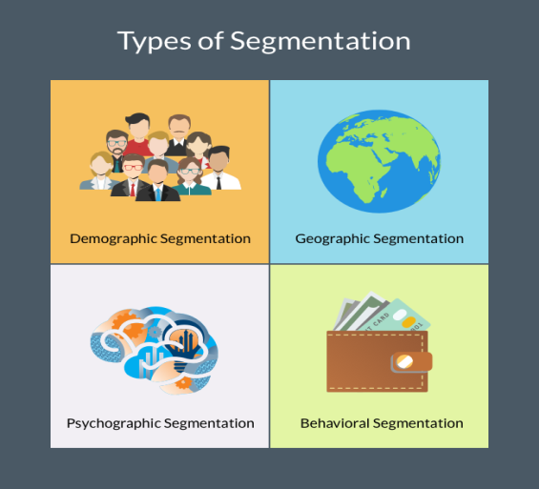

* Geographic Segmentation:
* Psychographic Segmentation:
* Behavioral Segmentation
* Purchase History Segmentation:
* RFM Analysis:
* Segmentation by Customer Lifecycle
* Needs-Based Segmentation:
* Usage-BasedSegmentation**:**
* B2B Customer Segmentation:
* Predictive Analytics Segmentation:
* Clustering Analysis:
* RFM with Machine Learning

5. DATA MODELING:

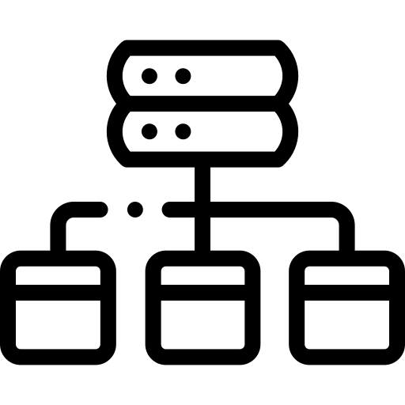

**Data modeling is the process of diagramming data flows. When creating a new or alternate database structure, the designer starts with a diagram of how data will flow into and out of the database**.

For example, e-commerce websites can process purchases and track inventory using the relational model.

TYPES:

**1. Conceptual Model**

**2. Logical Model**

**3. Physical Model**

6. SEGMENT DESCRIPTION:

Customer description, also known as customer profiling or customer persona creation, is the process of creating detailed profiles of different customer segments or individual customers. These descriptions provide a deeper understanding of customers' characteristics, needs, behaviors, preferences, and pain points. Customer descriptions are valuable for tailoring marketing efforts, improving customer experiences, and making data-driven business decisions. Here's how you can create customer descriptions:

* **Demographics**
* **Psychographics**
* **Behavioral Traits**
* **Needs and Pain Points**
* **Communication Preferences**
* **Value to the Business**
* **Competitive Landscape**
* **Segment Size**
* **Segment Goals**
* **Segment Name/Label**
* **Segment Illustration**

7. SEGMENTATION RESULTS:

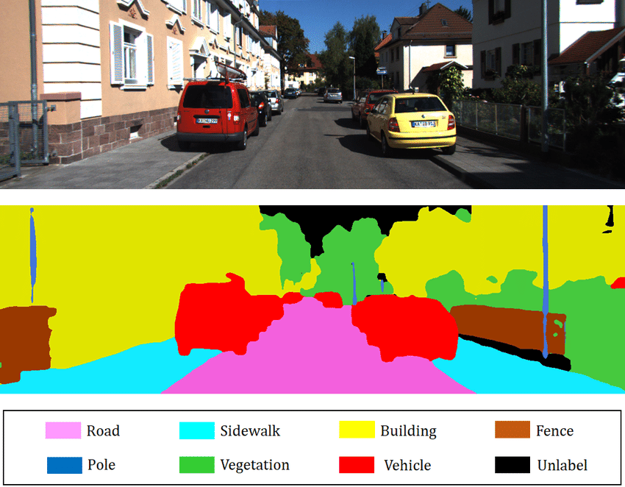

**Customer segmentation results in the creation of distinct customer segments or groups within a company's customer base.**

**1. Segment definitions**

**2. Segment profiles**

**3. Segment Size**

**4. Segment Characteristic**

**5. Segment Prioritization**

**6. Personalization**

**7. Performance measurement**

8. BUSINESS IMPACTS:

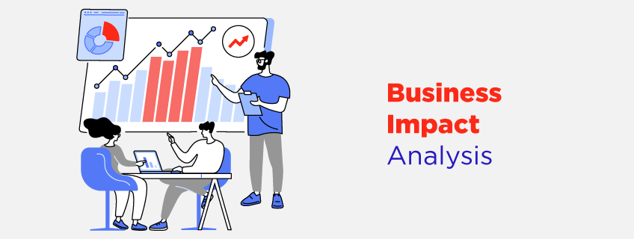

Business impacts of customer segmentation in brief:

1. **Improved Marketing:** Targeted campaigns, higher ROI.
2. **Increased Sales:** Tailored offerings, better conversion.
3. **Enhanced Customer Experience:** Personalization, loyalty.
4. **Cost Efficiency:** Resource allocation optimization.
5. **Customer Retention:** Targeted retention efforts.
6. **Product Innovation:** Tailored products and features.
7. **Pricing Optimization:** Maximized profits per segment.
8. **Market Expansion:** Identifying new opportunities.
9. **Data-Driven Decisions:** Informed strategies.
10. **Competitive Advantage:** Responsive to customer needs.
11. **Measurable Results:** Clear KPI tracking.
12. **Brand Loyalty:** Strong customer relationships.

|  |  |
| --- | --- |
|  |  |
|  |

**9. RECOMMENDATION:**



A customer recommendation is a voluntary suggestion or referral that customers make to their relatives and friends about their experiences with a business. This is usually done through word-of-mouth.

Start with simple things like customer service. Always be friendly, and respond to customer inquiries as fast as possible. Create a customer referral program that rewards your current customers for recommending you as well as your new customers for trying your brand out

Reviews and recommendations help customers make informed decisions. Both reviews and recommendations are a great way to hear from the horse's mouth. There's no over-selling or marketing waffle, it's just complete and utter truth from someone who has used the product or experienced the service.

10. IMPLEMENTATION FACTS:

While the project plan for the implementation phase will have the same components as that for the process review, there are four elements that I want to address explicitly: project leadership, communication, education, and running a pilot.

11. MONITORING AND EVALUATION:



Monitoring and evaluation (M&E) in customer segmentation:

1. **Set Objectives:** Establish clear goals for segmentation.
2. **Data Quality Check:** Regularly assess data accuracy.
3. **Track KPIs:** Monitor segment-specific key performance indicators.
4. **Segment Review:** Periodically validate and update segments.
5. **Market Trends:** Stay aware of market changes and trends.
6. **Experimentation:** Conduct tests to refine segment strategies.
7. **Customer Feedback:** Collect insights from customer feedback.
8. **Campaign Tracking:** Measure the performance of segment-specific campaigns.
9. **Satisfaction and Loyalty:** Monitor customer satisfaction and loyalty within segments.
10. **Profitability Analysis:** Assess segment profitability regularly.
11. **Technology Evaluation:** Review and upgrade segmentation tools as needed.
12. **Reporting:** Document and communicate M&E results for ongoing improvement.

M&E ensures segmentation remains effective and adaptable to changing customer needs and market dynamics.

|  |  |
| --- | --- |
|  |  |

12. CONCLUSION:

Customer segmentation, when executed effectively, leads to targeted marketing, increased sales, enhanced customer experiences, cost efficiency, and competitive advantage. Regular monitoring ensures adaptability to changing customer needs and market dynamics, ultimately driving business growth and customer satisfaction.

13. AKNOWLEDGEMENT:

We would like to extend our heartfelt appreciation to the following individuals and teams whose contributions and support were instrumental in the successful execution of our customer segmentation project:

We acknowledge the dedicated efforts of our project team members who worked tirelessly to collect, analyze, and interpret customer data. Their expertise and commitment have been pivotal in shaping the segmentation strategy.

Thank you for your dedication and collaboration.

Sincerely,

**- U. SNEHA SRI**

**CUSTOMER SEGMENTATION USING DATASCIENCE- GROUP 2**